Kiwiana
Deciding what makes Kiwiana depends a lot on who you are, your background culture and other influences that you have grown up with. For something to get the name Kiwiana it may have to meet the following requirements:
- Be recognised as familiar to many people across New Zealand
- Have stood the test of time (popular over time also)
- Hold a special memory or positive appeal
- It usually reflects a value/s or ideal/s that many people hold
- They are quite often unique to that community/country
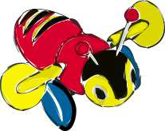
Here are some items that have been called Kiwiana.. can you spot any common reasons why they might belong together in the same set/classification? What makes them different to each other? Do you notice which set has the most items of “Kiwiana” in it? Why? Are there any you think should be here?

Buzzy Bee
Making a lot of noise as it is pulled around on a string, this toy was popular in many homes. There are many toys sold, so why did this bee become so popular? If you were a toy designer you would want toys to have features that help sell your item. Think about this, maybe do a PMI (Pluses, minuses, interesting.)

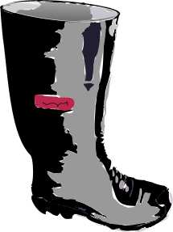
Black Singlet and Gumboots
Coming from the farming side of New Zealand life, the black singlet and gumboots represent the country and its importance to New Zealand. The black singlet is warm, covers up the sweat from hard, manual work and is sleeveless for freer movement. Gumboots are loved by all those who encounter mud on the farm or puddles on the footpath! A famous New Zealand comic called Fred Dagg used both the singlet and gumboots as props in his comic routines. Black is a national colour for New Zealand and it crops up in a number of other areas such as the, “All Blacks”. Checkout the gumboot song at: http://www.angelfire.com/co/fuzzywassyworld/thegumbootsong.htm

Fish & Chips
Shark and tattie… New Zealand has grown up with the corner fish & chip shop. But times change and a lot of other outdoor cafes and small restaurants with different menus have appeared. Large fast food chains have opened around the country. Fish & chips is still is probably one of the cheaper fast meals though. What do you think is the best fast food? How would you defend your ideas?

Jandals
Jandals entirely from rubber, they last for years and come in a variety of fashion colours . Popular for life in the summer sun including sunny beaches. The word Jandal comes from, "Japanese sandal" and became part of Kiwiana in the 1950's. Other countries call these "thongs or flip-flops".

Paua
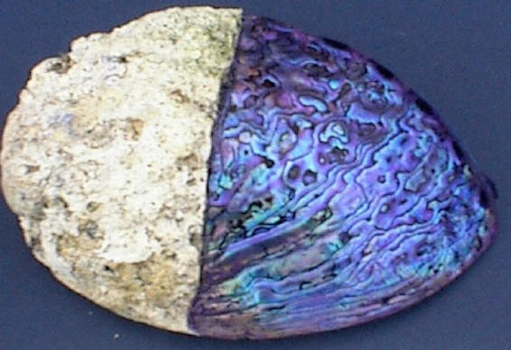
This is a shellfish that has a hard shell (pronounced pawa). The shell has a magical range of colours and is used for jewellery and the flesh is eaten by many. Paua (abalone) is a univalve shellfish that lives in rocky, coastal areas at depths between one and fifteen metres. It is an herbivore, eating seaweed and ranges in size from 7-14cm at maturity, but can grow to a maximum of 18cm. Paua grow larger in the cool South Island waters than they do in the warmer north.
Abalone are found throughout the world, but the New Zealand blackfoot has a unique blue/green iridescent (glowing) shell. Check out the paua house here: http://www.nzcountry.co.nz/html/fred_and_myrtle.htm

The Pipi
Fast food from the sea! Pipi, their relatives Tuatua and the much larger, rarer and controlled Toheroa, all belong to a family of shellfish unique to New Zealand. Shellfish have always formed part of the New Zealand diet. As New Zealand had no large animals to hunt (after the Moa became extinct) Maori had to be expert fishermen. While men went fishing, it was the women who collected the seafood shellfish on the shore. If you see people digging rapidly in the sand near the shoreline they maybe building a channel for that sandcastle.. or chasing the shellfish!

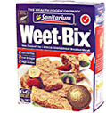
Weet-bix
A very popular breakfast cereal first made when there was less cereals on the supermarket shelves than today. Do you think it deserves the Kiwiana name? Would different groups of people be more likely to see it as “Kiwiana” More here: http://www.sanitarium.co.nz/schoproj/ppweet.htm

ANZAC Biscuits
Anzac Day has become more popular in recent years.. possibly the poppy will become a Kiwiana icon. Some think the ANZAC biscuit deserves this label… check out http://www.anzacday.org.au/miscellaneous/bikkies.html

Pavlova
This desert was named after the great Russian ballerina Anna Pavlova. Anna Pavlova (1881 - 1931) was the most famous classical ballerina of her era. She toured the world until 1925, including a visit to New Zealand where it is thought that a chef first prepared the dessert for her to honour her with a food as light and airy as her movements. Australians also claim to have crated the pav through a chef from Adelaide. Here are some quotes from Anna:
“To follow without halt, one aim; there is the secret of success. And success? What is it? I do not find it in the applause of the theatre. It lies rather in the satisfaction of accomplishment.”
“Master technique and then forget about it and be natural.”
“What exactly is success? For me it is to be found not in applause, but in the satisfaction of feeling that one is realising one's ideal.”
“As is the case in all branches of art, success depends in a very large measure upon individual initiative and exertion, and cannot be achieved except by dint of hard work. “
The ingredients of the pavlova are basically egg whites and sugar topped with whipped cream and kiwifruit (or strawberries). It can be a real challenge to make one with a crisp outside, chewy centre and that hasn’t fallen in the middle!

Hokey Pokey
Hokey pokey got to Kiwiana status more than fifty years ago. New Zealanders pack away about two million litres of hokey pokey a year.
New Zealanders started munching this flavour back in the 1940s when the range of ice creams was more limited than what we have today.
Hokey-pokey is made by adding toffee to vanilla ice cream. It used to have larger chunks when the hokey was smashed by machines but now it is regular, smooth “pebbles” of candy. The problems for the makers is to not make it too crunchy or too chewy as different people like the different textures in their mouths!
The top three ice cream flavours in the world are vanilla, chocolate and strawberry. In New Zealand it's vanilla, hokey-pokey, chocolate and strawberry.
"Ecce pocce", is Italian for "Get it here, it's cold", and it is thought that it became the name given to ice cream vendors as they called out to passerbys. Hokey-pokey actually referred to cheap ice cream or ice milk.

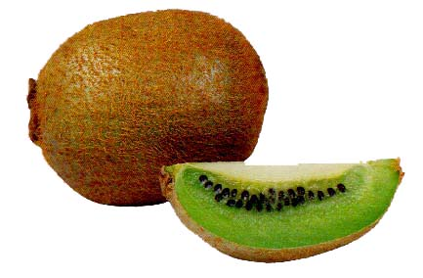
Kiwifruit
It is all in how you market. New Zealand is well known for its agricultural exports and expertise. New Zealand adopted this fruit from its home country in China where it was called the, “Chinese Gooseberry” and wasn’t that popular. The Kiwifruit farmers started growing in earnest in the 1960’s and then developed its size and taste. The fruit is now exported in its millions around the world. Checkout: http://www.night.net/tucker/st-kiwi.html-ss

The Edmonds Cook Book
Apart from the Bible, this is the best selling book in New Zealand, to date. It became a household name. All that is left of the Edmonds factory is the garden in Christchurch. Do you think this book would be selling as well today?
This book was cheap and had “kiwi” recipes and was sold in a time when cooking at home was more popular (when women were more usually at home as “home-makers” instead of being in the paid workforce)

Vegemite and Marmite
Vegemite and Marmite are yeast extracts. They are both very salty tasting, but Marmite is sweeter than Vegemite. Most people think that Vegemite has the stronger taste. I still remember my first “Taste” when some one spread great dollops on a wheat biscuit and I took a mouthful and gasped for water.. after that trick I learned to spread small amounts and like the taste! Can you think of a food that you have changed your mind about liking?

The Hot Dog
At the footie, stock car race, outside the local hardware, fairground, A & P Show, or school gala appears the hot dog stall.
The saveloy coated in batter becomes that crispy, red-sauce coated 'dog' on a stick. Sticking the icecream stick stick in one end made it portable so we could carry a fistful back to our 'mates'.

Meat Pie
Adapting meat-stew into a pastry-covered meal-on-the-run gave the Kiwi another fast food that is sold in the thousands each year. Every year a 'best pie in New Zealand' contest is held. Around New Zealand every year new flavours, with impossible ingredients are cooked up.. anything from possum meat to kangaroo meat can be used to create that 'unique' taste.

Chocolate Fish

A chocolate delight in the shape of a fish (celebrating our islands in the sea!). Well known throughout New Zealand these fish also represent celebrating something that is good.. like what someone has done.. give them a chocolate fish!

Kiwi
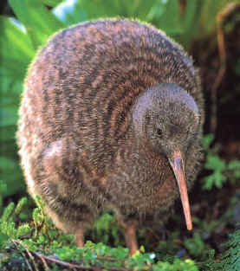
A kiwi is a rare flightless bird native to New Zealand. New Zealand has a reputation as being the country with the most unusual birds, especially ones that are flightless (Moa – extinct, and Kakapo for example). The Kiwi is both endangered and protected, and the kiwi become a symbol of this country.
The name 'Kiwi' is also slang for a New Zealander.

Silver Fern
Symbol for both sport and nature in New Zealand.

Rugby
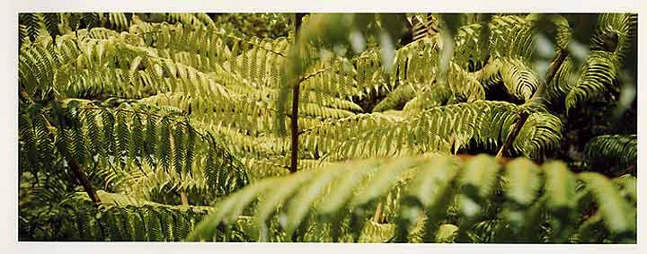
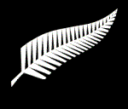
If the National Team of the “All Blacks” lose a game then some people seem to experience real deep disappointment. In a nation where sport has a high profile, the new professional era continues to raise new celebrities. Names such as Jonah Lomu, Christian Cullen, Andrew Merhtans, have become bankable items like other sports stars around the world. Is the emphasis placed on winning for our national teams seem right when balanced with the fact that most Kiwis are getting even less exercise than they used to? The Silver fern symbol is used on team jerseys. Many New Zealander's have strong opinions about the game, even if the match was one played years ago or just recently.

Netball
This sport for women and girls has a high profile in New Zealand. The symbol for the New Zealand team is the Silver Fern. Another popular version is the fast paced indoor netball that both men and women.

Number 8 Wire
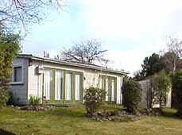
This wire is usually found on farms stapled in rows on fence posts. It began to represent “Kiwi ingenuity” as many other uses were found for it including as a repair tool. New Zealanders, isolated in rural farms, developed the “can do” attitude symbolised by number 8 wire. Today, in a world looking for constant innovation, this “can do” is now moving high-tech and represents the growing of ideas from “backyard” inventors.

Kiwi Bach

Lazy summer holidays or just a weekend escape, the bach represents the Kiwi love for getting away, enjoying the great outdoors and owning that "piece (peace) of country". In the South Island, the word ‘crib’ (meaning lodging or public house) is used, possibly borrowed from Charles Dickens in Oliver Twist. 'Bach’, a shortened version of ‘bachelor’, gives a feeling of 'being on my own'. A great place to go and re-charge the batteries and spend time with friends.


Lemon & Paeroa
L & P stands for Lemon and Paeroa, New Zealand’s most famous soft drink. It was invented in 1904 after its maker tasted some mineral water near the town of Paeroa, and mixed it with lemon to make a particularly refreshing drink. This drink is still popular throughout New Zealand today.

Sheep
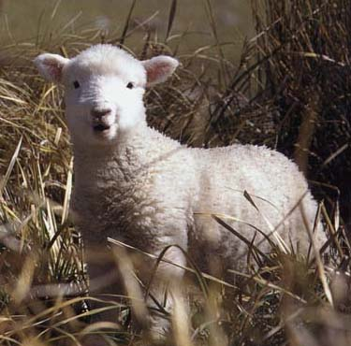
Representing the rural sector again, the sheep and the wool from its back have symbolised the rural nature of New Zealand. Some people in overseas countries think Aoteraroa is all green grass when they learn that there are 50 million sheep and only 4 million people.

New Kiwiana?

Americas Cup
This cup could be a symbol for the sailing nature of kiwis. Auckland, the largest city in New Zealand, is known as the “city of sails”.

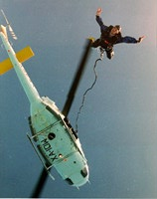
Bunjee Jumping
This elastic fantastic, adrenaline plunge was invented in New Zealand. Like number 8 wire it illustrates the innovation side of kiwis but it also combines with our love of sports.

New Zealand's National Flag
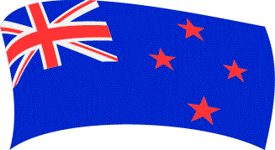The Union Jack in the top left represents our history as a British colony. The blue represents the Pacific Ocean and the stars represent the Southern Cross constellation.

Maoritanga pronunciation, haka, place names
Maoritanga is Maori culture; a way of life and view of the world. The question to ask is, can Maoritanga or parts of it be called Kiwiana?

Kia Ora
This phrase is a general expression of wishing good fortune and all other good things to the recipient. Kia Ora is probably the most common Maori greeting.

The Haka
Many people associate immediately this powerful challenging “dance” with New Zealand. A haka is a challenge to the opposing tribe who may have responded in a similar way. It is important that the haka is performed with sensitivity to the cultural norms that surround it.

Maori Place Names
Over recent decades Maori words have appeared in more common language use. These include Aotereroa (Land of the Long White Cloud) to kai (food) & whanau (family- including extended family). Are there any other Maori that you think are both known by all cultures?

Pohutukawa
Mainland Pohutukawa (M. excelsa) is found all over New Zealand, but has a natural growing range is north from an invisible line stretching from New Plymouth to Gisborne. It has bigger, more elongated leaves, the fuzzy underside of its leaves and by its larger flowers than a similar tree called, Rata. It has become a symbol for Christmas as it flowers around that time of year and its bright red flowers remind all of summer ahead.

Activities
http://www.photosource.co.nz/image_gallery.cfm?fuseaction=DisplayThumbs&CategoryID=97
http://kiwicards.newzealand.co.nz/pages/Kiwiana/index.html
http://xtramsn.co.nz/travel/0,,8425-1472617,00.html Kiwiana Festival

Schoolwiana/Communityana
If there was a symbol for your school or community what would it be? What values or ideals does it reflect?

