The Mystery of Culture
Mystery is delightful and exciting, but it is foolish to admire it too highly. A thing is mysterious merely because it is unknown. There will always be mysteries because there will always be unknown and unknowable things. But it is best to know what is knowable.
Culture consists in patterned ways of thinking, feeling and reacting. The essential core of culture consists of traditional ideas and especially their attached values.
Clyde Kluckhohn.

—Aldous Huxley, Along the Road
Do you agree.. Explore the mysteries of culture!!
It only takes seven seconds for us to make a decision about what a person is like when we first meet them. We make this decision based on our own perceptions, world view and culture.- Tupperware training.
Are we really like this?

Culture Definitions
Culture is any behaviours or knowledge learned from others in the groups to which we belong. There are visible (symbols, icons) and invisible parts of culture (the reasons why we behave the way we do). The essential core of culture consists of traditional ideas and especially their attached values.
Culture the things about the way we live that make us unique, that reflect what we think is valuable.
Culture is the pattern of things that we learn and that influence us including: knowledge, beliefs, art, religion, morals, customs and the behaviour and thoughts of others. OR
Simple Versions
Culture is the shared set of assumptions, values, and beliefs of a group of people by which they organize their common life. —Gary Wederspahn OR
Culture is systems of human meaning

A Closer Look at Culture
Culture is a bit like a tree.. it is the roots that supply all the life and nutrients and reasons for living that we have. The leaves and branches show off the culture and are the things we can see that represent the culture at work.
Surface behaviours are influenced by beneath the- surface values and assumptions.

Culture can also be compared to an iceberg. Just as an iceberg has a visible section above the waterline, and a larger, invisible section below the water line, so culture has some aspects that are observable and others that can only be suspected, imagined, or intuited (deducted). Also like an iceberg, that part of culture that is visible (observable behaviour) is only a small part of a much bigger whole.
It is easy to pick out some aspects of a culture that are obvious because they are promoted by media and to think that this means the people are likely to behave in a certain way. However, it is important to realise that there are visible and invisible aspects to culture. Also, some parts of the visible culture are more likely to be seen because they are more popular, dramatic, controversial or colourful.
The invisible culture is the underlying values and assumptions of a society and the visible culture or culture in the flesh is the specific behaviours that come from the invisible values. It is important to understand that what people do and say in a particular culture, are not random and spontaneous, but are consistent with what people in that culture value and believe in. By knowing people’s values and beliefs, you can come to expect and predict their behaviour.

Three Dimensions of Behaviour
universal refers to ways in which all people in all groups are the same
cultural refers to what a particular group of people have in common with each other and how they are different from every other group
personal describes the ways in which each one of us is different from everyone else, including those in our group
These are two important points for you to remember:
1. Because of universal behaviour, not everything about people in a different culture is going to be different; you will have things in common
2. Because of personal behaviour, not everything you learn about a different culture is going to apply in equal measure, or at all, to every individual in that culture.
Any behaviour has two meanings
- the meaning given to it by the person who does the action, and
- the meaning given to it by the person who observes the action

Levels of Culture
There are different types or levels of culture. A family can have a culture.. ways and patterns of doing things. Any group or gang that has existed for a length of time will build up its own culture. A school, city, province, or country can have a culture. The deaf community has its own culture as will any other group that exists because of their disability, ability or affinity of the people to each other. A sport can have a culture as it is fleshed out at a school, club and national level.
Within, alongside or through one culture another one can exist. We can all be in more than one culture. A racial group will have its own culture that could be seen on a national level or it may be a small group within one province or state of a country. Some racial groups that are smaller may be as sets within a more dominant culture.
Countries with one culture are called monocultural. Countries with two more dominant cultures are called bicultural and those with many dominant cultures are multicultural.

Where do Cultures come from?
A country inherits its culture or cultures from history. Like many countries, African nations were drawn on a map when they were created by the Colonial Empires. Because the “makers” of these countries did not look at the ethnic groups (people, tribe or racial groups) within these countries they made, they often split ethnic groups and forced them to be in the same country. This can cause tension and resentment between cultural groups, especially if one people group is favoured.
Some cultures are very strong and are treasured and so people work hard to preserve and maintain them. Cultures can be preserved in a number of ways, but most importantly through a genuine appreciation and participation by a general population. If this is backed by government support and support from the arts a culture will continue to develop its uniqueness.
Culture connects us with the past but it is also a changing thing. As the country you live in is changed by outside influences, or changes in response to the environment or things that happen within the culture, then often over time the culture will also change as peoples’ patterns of behaviour change.
Cultures can influence each other from the distance today. Through media such as internet, newspaper, magazines, TV, film, video, DVD and radio one culture can influence another. For instance, many countries see that one of the world dominant cultures is “American”. The culture of America is naturally dominant because of its size, influence in the world, and its commercial companies that take American culture and spread it wherever they go. It is important to note though, that only certain aspects of a culture are transmitted easily via media and so these do not necessarily represent the “Truth” of what a culture is like.
We learn our own individual and group from the day we are born. We pick up our culture through role models in our family (parents and other brothers and sisters) and from other children and adults. We are like sponges collecting in our family culture, school and countries culture, often without noticing we have changed or modified our patterns of thinking or behaving. We observe, imitate, have a behaviour reinforced by others, and finally carry out that behaviour without thinking (it is mastered). Culture is passed on from one generation to another in so many different ways.
Attitudes to culture and its importance change. Today people are more sensitive to culture and treasuring the colour and vibrancy of traditional culture.
For many people in our world their culture can be a thing that locks them into a certain life. Depending on where they are born and what group, tribe or caste they are born into they can be forced to live a certain way or are told what they can or cannot do. This is because the culture of the country is intertwined within how the country is governed and so the laws, government and those who enforce these laws. Your gender (male or female) can be influenced by culture. In many countries still today if you are born as a woman it means that there are certain things you can or cannot do. It is the same for the man but you will note that the man is allowed to do things that give him economic or social freedom (he is allowed to be educated, he can hold jobs with power, he can marry who he chooses, he can choose his career).
In looking at culture it is often important to give examples or generalisations. Treat these generalisations with scepticism and wariness. They can give you potentially accurate and useful information, but the actual accuracy and usefulness will depend on the context and specific circumstances. You can get a prejudice from a generalisation!
For instance it would be wrong to get the impression that all of us are affected the same way by the culture around us. Just because we are a certain gender does not mean that we behave in the way our culture influences us. Our own individual beliefs, age, family background, whether we grew up in the country or city, all make our reaction to the same culture different. Some people stand out against the aspects of a countries culture more strongly than others because of their own personality.

New Zealand Culture
New Zealand has a unique culture that is interesting to look at because it was one of the last countries in the world to be settled. Polynesian settlers arrived in number around 1000BC-1400BC and various tribes settled parts of the South Island and North Island. These people, within their various tribes have became known as, “Maoris”. In the 1800’s New Zealand was also the last country to be settled by Europeans, mainly from England and Ireland, bringing with them European culture.
At this time it many individuals saw that the Maori culture was primitive and godless. Because of this it was decided by many that the only way to help them was to teach Maoris how to be European. Dress them and teach them to be European, and even though their skin colour is different they will come out all right. Even as some traders, early officials and missionaries were doing this, others treated the Maori culture with far more respect. They understood each others rights more deeply. This shows us that even though we all are in a culture we can still make individual decisions on how important people and their ways of living are to us.
Through these individuals (Maori Chiefs, missionaries and other individuals) first a declaration of independence was signed in 1835 and then in 1840 a treaty for how the two cultures would act towards each other was put into place. It was to protect Maori tribes from exploitation by Europeans out to make money and/or to seize power from Maori. This makes New Zealand unique as having an official treaty (The Treaty of Waitangi) that records the way the two cultures will respect each other.
Unfortunately, words on paper (there were two versions of the Treaty, English and Maori, that differed and could be interpreted in different ways) are one thing and actions are another. Much land was still confiscated, taken or traded illegally from the Maori tribes and more importantly the respect the Treaty organisers tried to set up between the cultures was lost.
In Maori culture the tribe owned the land, European culture was focused more on the individuals rights.
The rapid adoption of Christianity, impact of new technology (metal tools) and diseases, and the influence of a dominant European culture broke down traditional Maori customs and lifestyle. For a long time in New Zealand the Maori culture virtually disappeared within the European culture as Maoris had little power (mana) within the new society. The Maori population did not recover to the Pre-European levels until the 1940’s. Aspects of the traditional Maori way of life were preserved through tribes and individuals but the government recognition and support for Maori culture was limited. Popular Kiwi culture had little place for a true respect for taha Maori apart from limited “tourist” and showy aspects. Within the last 40 years the Maori culture has re-surged once again. The Maori language has been officially recognised, government agencies and, but possibly more importantly the respect for Maori culture I the general population has grown enormously. An appreciation of this is also made stronger as other Pacific cultures infuse New Zealand. There are signs that show New Zealand’s population still struggles to truly be bi-cultural as health, crime and economic statistics still favour the European culture, but it is generally seen that a corner has been turned.
New Zealand’s culture is being increasing influenced through the immigration of other people groups also. As more Chinese, Korean (amongst many other Asian groups), South African and Pacific Island immigrants come to New Zealand their impact will grow.
As New Zealand has a much smaller population overall, and has a less stronger European cultural history, it is possible that the changes there will provide an interesting picture of what other larger countries will experience. Of course, the influence of other world cultures via the media is not to be underrated. If we unconsciously absorb and model ourselves on what we see and hear, and as media seems to become even more prevalent then change will continue to accelerate.
It is possibly for this reason that celebration and respect of the history of New Zealand (ANZAC day for instance) is far stronger than it used to be. A resurgence in appreciation of Maori culture, New Zealand music and a willingness to be proud to be a “Kiwi” have also been noted. Will New Zealand therefore become a nation with a stronger core awareness of “Kiwi” biculturalism with a larger awareness of a multicultural world around us or will New Zealand become a country of “grey culture” with no distinct flavour?

Snapshots of New Zealand Culture
- There are more golf courses in New Zealand per capita of population, than any other country in the world (over 400 golf courses for 3.7 million people).
- Auckland has the largest number of boats per head of population than any other city in the world.
- New Zealand was the first country to give women the vote (1893).
- New Zealand was the first country in the world to have a government department for tourism. In 1901 the Department of Tourist and Health Resorts was created.
- New Zealanders are heavily involved in outdoors activities. Our national image and the lifestyles of the population have been largely shaped by our involvement in a wide variety of sports and leisure activities. It is often said that sports and leisure are the predominant focus of the New Zealand cultural identity, for example, New Zealand’s involvement in international rugby.

From Hillary Sport/Leisure Commission
- Almost everyone in New Zealand aged five and over enjoys some sport or active leisure. Two out of three people are active and enjoy the benefits this brings, but one in three New Zealanders are insufficiently active. For many this poses a serious health risk. The coach potato index (cpi) for adults is 34 (34% are inactive).
- Over 200,000 young people and almost 900,000 adults are not active for the minimum time recommended for a healthy lifestyle (about 30 minutes per day).

Statistics NZ Cultural Survey:
- Maori 5 minutes day average on Maori Cultural activity. Other ethnic groups did not register an average
- Visits to museums, art galleries, archives and historic places 1.5 hours a year
- Reading 44 minutes a day
- 15.9 hours year performing in a performing arts
- 6 hours a year watching performing arts
- 8.3 hours year cinema
- 2 hours day TV or video
- 8 minutes day radio or music
- 23 hours year on religious activities
- 2.3 hours on community events

Other Relevant Statistics
- Over half (52 percent) of all New Zealanders were living in just four main urban areas (Auckland, Hamilton, Wellington and Christchurch) at 30 June 2002 .

http://www.stats.govt.nz/domino/external/web/Prod_Serv.nsf/htmldocs/Arts+and+Culture

Actual Date
1998 Observance

New Years Day
1 January
Thursday 1 January

Day after New Years Day
2 January
Friday 2 January

Waitangi Day
6 February
Friday 6 February

Good Friday
varies
Friday 10 April

Easter Monday
varies
Monday 13 April

ANZAC Day
25 April
Saturday 25 April

Queen's Birthday
1st Monday in June
Monday 1 June

Labour Day
4th Monday in October
Monday 26 October

Christmas Day
25 December
Friday 25 December

Boxing Day
The unofficial festivals in New Zealand probably give more awareness of the culture of New Zealand. There are festivals of the Arts, film, music, dance and drama festivals, food festivals, wine festivals, agricultural field days, and a number of cultural performance festivals such as Kapa Haka competitions. Many cities also hold summer entertainment festivals including many family events.

Big Hairy Questions
- Who /What influences me to be me?
- What are the major changes in your culture recently?
- How does culture affect our life? What are the consequences of this?… (so what?)
- What are the 5 major changes to my culture in the last decade?
- What technology influences culture change?
- How do cultures change? (over time, vehicle of change)
- How much does money (your socio-economic background) affect the culture you grow up with?
- Do all families have the same strength of culture? If so what makes them the same/different?
- How does culture affect a person?
- Can a school, club etc have a culture?
- Do symbols really tell us about what people feel or are they a stereotype?
- What is a gang culture?
- What is globalization of culture?
- How did this experience change your opinion of different cultures? Be specific.
- Why is it important to respect and tolerate people's culture?
- How can our class use this information about culture, to resolve any future conflicts?
- If you were placed in an entirely different culture, what parts of your culture would you “forget/lose” first?
- Name a particular quality that you think is difficult to understand in another culture? Why?
- Looking at a third world culture being challenged by a first world one.. what recommendations for allowing sensible change would you make?
- Does a culture keep people in poverty?
- Does a culture stop people from keeping up with or in contact with the outside world?
- If everyone doesn’t speak the same language how
- Is culture affected by what gender we are?
- What is a native culture?
- What specific aspect of your culture do you most appreciate and never want to lose?
- Why are differences seen, sometimes, as bad or wrong?
- What is your culture?
- Describe the geographic location (climate, natural resources, etc.) of your culture.
- Who were the early inhabitants of this region? What were some of their contributions to the contemporary culture?
- What are some of the important traditions and ceremonies in this culture? Describe at least three of them in detail.
- How are the people in your culture governed? Explain how laws are made, who enforces them and how disputes are settled.
- What are the important religions in your culture? Explain some of their basic philosophies, beliefs, sacred objects and how they worship.
- What are some of the recreational activities that people in your culture enjoy? Describe at least three of them in detail.
- What is school like in your culture? Explain how people in your society learn to do new things.
- What languages are spoken in your culture? Are there any sacred languages? What kinds of writing do they use?
- Are men and women treated differently in your society? In what ways? Are there things that one group can do which are forbidden to the other group?
- If you sending a mission to meet aliens what cultural item or photo of one would you send? These aliens can touch an item and sense the meaning and cultural significance of the item.
- Who are 5 influential persons from your culture? What are/were their major contributions?
- If you could create your own culture what would be the top ten things you would have in it?
- Personality is not part of culture, but does it affect culture or the way we interact with culture?
TOP 10
What is the main religion? How does it reflect culture?
What foods do they eat? Why? How does it reflects their culture?
Does their technology influence their culture
How does the land weather affect the culture?
Does the colour of skin affect culture why/How?
How does housing shelter affect/reflect culture?
What 3 things about the culture keep them in their country?
How does their education affect/reflect culture?
How do plants animals reflect/affect culture?
How does sport reflect/affect culture?
Do the laws and punishments reflect their culture?
Does the size of population affect culture?
Does the culture have special ways of travelling?
How open is your culture to recognising and appreciating other cultures? If you are a more open culture does this mean you lose your own culture more quickly?

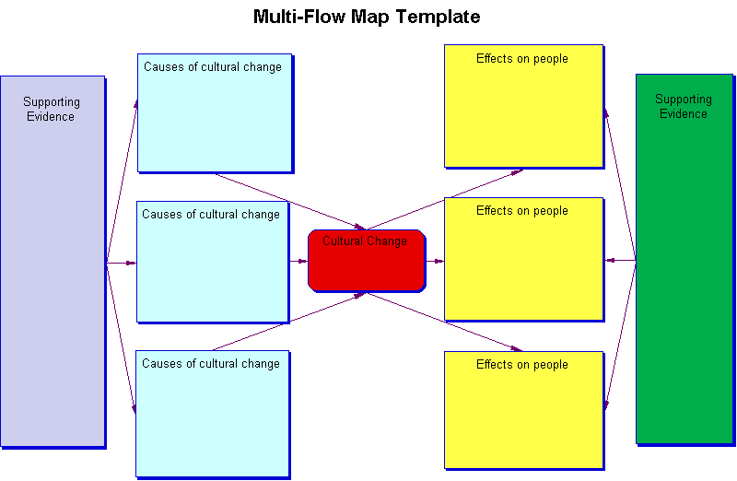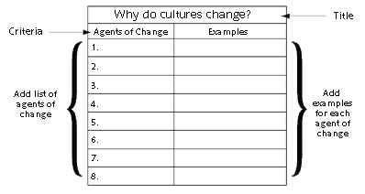

Adaptation Resources
Melting Pot
Take a pinch of white man
Wrap him up in black skin
Add a touch of blue blood
And a little bitty bit of red\
Indian boy
Oh like a Curly Latin kinkies
Oh Lordy, Lordy, mixed with yellow Chinkees, yeah
You know you lump it all together
And you got a recipe for a get along scene
Oh what a beautiful dream
If it could only come true, you know, you know
What we need is a great big melting pot
Big enough enough enough to take
The world and all its got
And keep it stirring for
A hundred years or more
And turn out coffee coloured people by the score
Rabbis and the friars
Vishnus and the gurus
We got the Beatles or the Sun God
Well it really doesn't matter
What religion you choose
And be thankful little Mrs. Graceful
You know that livin' could be tasteful
We should all get together in a lovin machine
I think I'll call up the queen
It' s only fair that she knows, you know, you know
What we need is a great big melting pot
Big enough enough enough to take
The world and all its got
And keep it stirring for
A hundred years or more
And turn out coffee coloured people by the score
Coffee coloured people
Coffee coloured people
Coffee coloured people by the score

Discussing Symbols
Can the reader or the audience the sign is designed for, read and understand the sign?
Has colour been used effectively for example, red for danger signs?
Does the overall design or shape of the sign or symbol, grab the reader's attention?
If verbal features have been used, has the impact been through the use of upper case letters, lower case letters or the use of both?
If pictures have been used are they easily identifiable to the reader?

Elements of Culture
Language
Customs and traditions
Holiday customs
Celebrations
Beliefs/religion
Religious rituals
Physical racial feature
Music
Food
Humour
Leisure
Sport
Gender roles
Education
Knowledge
Icons
Entertainment
Myths and legends
View of Status and leadership
Literature
Values
Housing
Social organisation
Heritages
Government
Law
Economic structures
Ideas about clothing. Styles of dress
Importance of time
Attitudes about personal space/privacy
Concept of self
Literature
Art- what is unique to country (subject/Style)
Music
Dancing
The role of family
Beliefs about child raising (children and teens)
Beliefs about the responsibilities of children and teens
Concept of fairness
Nature of friendship
Rules of polite behaviour
Concept of self
Work ethic
Beliefs about hospitality
Gestures/body language including facial expressions and hand gestures
Ways of greeting people
Work ethic
Concept of beauty
Rules of polite behaviour
Attitude toward age
General worldview
1. Organise and add these to your culture mindmap.
Tip: Colour code easy elements into the sets that they belong to first to make it easier
2. Place them onto the cultural iceberg. Observable aspects above the waterline, unobservable below.

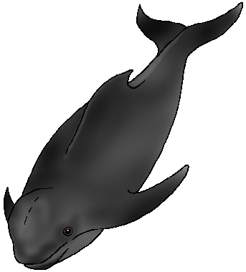
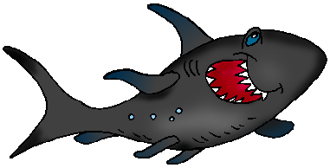


Cultural Iceberg

Match the Behaviour to the Value or Belief
Value/Belief | Behaviour/Action
Family is important
Saving Face is important | Not laying off a worker because they have turned 60.
Sport is important | Telling someone you have started the work when you really haven’t
I can disagree with my friend | Inviting the cleaning staff to end of year celebration with other workers
Respect for age | Choosing to go out on a family night rather than go to a friends house
All people are equal | Saying, “I’m not interested. I don’t think it’s a good idea” when a friend says I’m a chicken for not shoplifting with them
People should be honest | I’m not wearing a tie
It’s OK to be informal | We’ve got Sky TV to watch the rugby and soccer
Behaviour makes more sense when you understand the value or belief behind it.

Universal, Cultural or Personal
This next exercise contains a list of behaviours. In the space before each of them, put a “U” if you think the behaviour is universal,“C” if it is cultural, or “P” if it is personal.
Sleeping with a bedroom window open.
Running from a dangerous animal.
Considering snakes to be “evil.”
Men opening doors for women.
Respecting older people.
Liking spicy food.
Preferring playing soccer to reading a book.
Eating regularly.
Eating with knife, fork, and spoon.
Being wary of strangers.
Calling a waiter with a hissing sound.
Regretting being the cause of an accident.
Feeling sad at the death of your mother.
Wearing white mourning robes for 30 days after the death of your mother.
Not liking wearing mourning robes for 30 days after the death of your mother.

Behaviour Detective
Try and spot over the week behaviours you can put into each category. Go for 5.

Universal
1
2
3
4
5

Cultural
1
2
3
4
5

Personal
1
2
3
4
5

While people have to
learn most of their
behavior, after they
learn it they come to
regard that behavior as
natural and normal— for everyone.

1. Something you are just becoming aware of and perhaps observing closely but not yet doing.

2. Something you have just begun to try doing.

3. Something you’ve done once or twice but haven’t mastered yet.

4. Something you have recently mastered.

5. Something you now do without thinking.

Spotting values in Everyday sayings!
1. He thinks he’s better than so and so.
2. She’s always putting on airs.
3. That person should be cut down to size.
4. It’s gone to his head.
Value/belief: ________________________________
1. Talk is cheap.
2. Put your money where your mouth is.
3. He’s all talk and no action.
Value/belief: ________________________________
4. She’s always beating around the bush.
5. Tell it like it is.
6. Straight talk, straight answer, straight shooter.
Value/belief: ________________________________
7. She did something with her life.
8. Nice guys finish last.
Value/belief: ________________________________
9. Every cloud has a silver lining.
10. Look on the bright side.
11. Tomorrow is another day.
Value/belief: ________________________________
12. Where there’s a will there’s a way.
Value/belief: ________________________________
13. Stand on your own two feet.
Value/belief: ________________________________
14. Don’t judge a book by its cover.
15. All that glitters isn’t gold.
Value/belief: ________________________________
16. Nothing ventured, nothing gained.
Value/belief: ________________________________

14 Views of the World
Where does our culture fit into these? Picture how we react under each heading.

VIEW OF AGE
- Emphasize physical beauty and youth.
- Fire older people to hire younger people for less money.
- Judge a worker’s worth based on production, not seniority.
- Old people live in retirement villages

CONCEPT OF FATE AND DESTINY
- You can be whatever you want to be.
- Where there’s a will there’s a way.
- Do it yourself, rags-to-riches.

VIEW OF HUMAN NATURE
- Courts consider a person innocent until he/she is proven guilty.
- People should be given the benefit of the doubt.
- If left alone, people will do the right thing.
- We need to discover how a vicious killer “went wrong.”

CONCEPT OF TIME
- A timetable is important
- You should arrive on time to meetings
- It is wrong to be late

VIEW OF STATUS/LEADERSHIP
- Achieved or subscribed.
- People should have status by the family they are born in
- You have to work to achieve status
- Leaders should be elected by democratic vote

ATTITUDE TOWARDS CHANGE
- New is better.
- A better way can always be found; things can always be improved upon.
- Just because we’ve always done it that way doesn’t make it right.

ATTITUDE TOWARDS TAKING RISKS
- A low level of personal savings
- You can always start over.
- Nothing ventured, nothing gained.
- A high level of personal bankruptcies is common.

CONCEPT OF SUFFERING AND MISFORTUNE
- People rush to cheer up a friend who’s depressed.
- If you’re unhappy, take a pill or see a psychiatrist.
- Be happy.

CONCEPT OF FACE
- It’s important to tell it like it is, be straight with people.
- Confrontation is sometimes necessary to clear the air.
- Honesty is the best policy.

SOURCE OF SELF ESTEEM SELF WORTH
- People judge you by how much money or success you have.
- First question at a party is, “What do you do?”
- Material possessions measure success.

CONCEPT OF EQUALITY
- People try to treat everyone the same.
- The President or Primeminister is not much different to us.
- Putting on airs is frowned upon.

ATTITUDE TOWARDS FORMALITY
- Telling someone to help themselves to what’s in the refrigerator is common.
- Using first names with people you’ve just met is fine.
- Using titles like “Dr”. for someone with a Ph.D. is overdoing it.

ATTITUDE TOWARDS DOING
- Doing is preferred over talking.
- The absent-minded professor, the ivory tower reflect anti-intellectualism.
- Be practical.
- Arts are an adornment of life but not central to it.

VIEW OF THE NATURAL WORLD
- Building dams to control rivers.
- Use technology to beat natural problems
- Spending lots of money annually on weather prediction.
- Kill flies with fly spray

VIEW OF FAMILY
- Each child has different needs
- Children will leave home in their late teens
- Relatives do not have to be visited often
- World Jeopardy
Design cards to answer the following questions

Culture Quotes
Television is the first truly democratic culture - the first culture available to everybody and entirely governed by what the people want. The most terrifying thing is what people do want.
Clive Barnes

A Single Lucid Moment By Robert Soderstrom
Returned Peace Corps Volunteer, Papua New Guinea

As the plane buzzed back over the mountains, it was now just us and the villagers of Maimafu. My wife, Kerry, and I were assigned to this village of 800 people in the Eastern Highlands Province of Papua New Guinea. It looked as if we were in for a true Indiana Jones adventure!
The mountains were dramatic and thick with rain forest. No roads had ever scarred them. We had loaded a four-seater plane with cargo (we would fly out every three months to resupply) and flew for 30 bumpy minutes southwest to the mountain ridges. From the plane, the village looked very much like a shoe-box panorama from a grade-school science project.
My wife and I were the first Peace Corps Volunteers ever in Maimafu. We had been greeted by a large group of beautiful people, all wearing gorgeous, curious smiles. Giggling, naked children hid behind trees during the trek down the mountain to our new home, and a lively entourage followed using their heads to carry our boxed supplies through the muddy trails. It was quickly becoming clear that we had just been adopted by a very large and unique family.
The basic culture of subsistence living had not been replaced; there were no cars, electricity, or telephones—just grass huts, large gardens, and a whole lot of rain forest. The women spent the day in the gardens planting, weeding, and harvesting. The men grew coffee, from which they generated their sole income of about $200 a year. The village had lived in harmony with its natural surroundings for millenniums.
The villagers had built us a beautiful, bamboo-thatched hut on short stilts. Planted behind the house was a three-acre garden, carefully tended and ready to harvest. Its bounty included corn, greens, tomatoes, beans, peanuts, onions, potatoes, and pineapples. To top it all off, the path to our new home was sprinkled with flower petals the day we arrived.
It quickly became clear that Maimafu was a preserved example of communal living. Men rallied to the building of a new home, the elderly worked and lived with their families, and mothers breast-fed their neighbours’ children. In fact, the one parentless, Down’s syndrome man in our village was fed, housed, and clothed by everyone; he would spend a few days with one family before happily wandering in to work or play with the next.
It was when we had settled in that it happened. We were sitting in a circle on the ground with a large group of villagers to “tok stori,” Papua New Guinea’s favourite pastime of “telling stories.” I had passed around photos I had snapped back home in Chicago. A villager was staring intently at one of the photos. He had spotted two homeless men on a Michigan Avenue sidewalk with crude signs propped between their legs.
“Tupela man wokem wanem?” he asked. (What are these two men doing?) I attempted to explain the concept of homelessness to the group, and the desire of these two men to get some food. Crowding around the photograph for a good stare, the villagers could not comprehend how the men became homeless, or why the passersby in the photo were so indifferent. They bombarded me with questions and I did my best to make sense of the two ragged beggars in the midst of such glittering skyscrapers. I read from their questions and solemn mood that they had made an important observation—these two men must lack not only food and shelter but also a general sense of affection and purpose in their community.
Early the next morning, we were startled to hear a sharp rap at the door. Opening it, I was greeted by Moia, Kabarae, Kavalo, and Lemek. Kerry and I went out into the bright beautiful day and sat with them in a circle. Each man gave us a pineapple. Moia spoke: “After you left last night, all of us men on the village council had a very big meeting. For a long, long time we discussed the two men in your picture. We have reached a conclusion and have a proposal for you.”
“What could this possibly be?” we wondered.
“Please contact those two men as well as your government. Ask the government if they will fly those two men to Maimafu, just like they did for you. We have marked two spots of land where we will build houses for those two men, just like we built for you. Our men will build the houses and the women will plant the gardens to feed them.”
They were offering to do what? I was stunned and overwhelmed. Their offer was bold and genuine. It was innocent and naive. It was beautiful. And, like the twist of a kaleidoscope, my worldview had completely changed. What does one say to such an offer? We stammered for a response and stumbled over explanations of difficult logistics, scarce money, and government bureaucracies.
But the councilmen would not accept no for an answer. In their simple lives, it was impossible to comprehend that humanity was host to such an injustice. They wanted action.
The villagers were serious. They were offering everything they had. We reluctantly matched their enthusiasm with a few letters to America and long conversations with the village council. We toured the sites where the homes were to be built. We listened to the women discuss the types of gardens they would plant, which would even include coffee trees to generate a small income. And we answered numerous questions over time from villagers amazed with this foreign thing called homelessness. The plan could not work, we told them. Their hearts sank, and I could see in their eyes that this dream would not die easily.
“Sori tru, sori tru we no inap wokem dospela samting,” they told us (We are sorry this can't happen). They clicked their tongues and shook their heads in disappointment.
Initially inspired by the episode, I began mulling questions over and over in my mind. Fetching water in the ink-black night and looking up the hill at our small hut, light from the lantern inside splitting the bamboo-thatched walls, I would think of the spiritual wealth of Maimafu and the material wealth of America: Can a community reach a balance of material wealth and spiritual wealth? Why do these two societies exhibit so much of one and not much of the other? Do those two ends interfere with each other? How much spiritual wealth can we have? How much material wealth do we need? How has the world evolved so that some people own mansions and others lack shoes? How many people have love in their souls but diseased water in their drinking cups?
The villagers worked with us on newer projects. And, I discovered, like many Peace Corps Volunteers before me, that the world’s purest form of brotherhood can often be found in the smallest of villages.
Culture is the outward expression of a unifying and consistent vision brought by a particular community to its confrontation with such core issues as the origins of the cosmos, the harsh unpredictability of the natural environment, the nature of society, and humankind’s place in the order of things.
—Edward Hall

What do you see?
Long ago six old men lived in a village in India. Each was born blind. The other villagers loved the old men and kept them away from harm. Since the blind men could not see the world for themselves, they had to imagine many of its wonders. They listened carefully to the stories told by travellers to learn what they could about life outside the village.
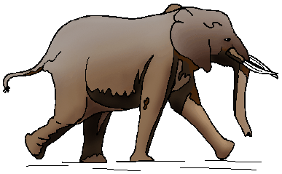
The men were curious about many of the stories they heard, but they were most curious about elephants. They were told that elephants could trample forests, carry huge burdens, and frighten young and old with their loud trumpet calls. But they also knew that the Rajah's daughter rode an elephant when she travelled in her father's kingdom. Would the Rajah let his daughter get near such a dangerous creature?
The old men argued day and night about elephants. "An elephant must be a powerful giant," claimed the first blind man. He had heard stories about elephants being used to clear forests and build roads.
"No, you must be wrong," argued the second blind man. "An elephant must be graceful and gentle if a princess is to ride on its back."
"You're wrong! I have heard that an elephant can pierce a man's heart with its terrible horn," said the third blind man.
"Please," said the fourth blind man. "You are all mistaken. An elephant is nothing more than a large sort of cow. You know how people exaggerate."
"I am sure that an elephant is something magical," said the fifth blind man. "That would explain why the Rajah's daughter can travel safely throughout the kingdom."
"I don't believe elephants exist at all," declared the sixth blind man. "I think we are the victims of a cruel joke."
Finally, the villagers grew tired of all the arguments, and they arranged for the curious men to visit the palace of the Rajah to learn the truth about elephants. A young boy from their village was selected to guide the blind men on their journey. The smallest man put his hand on the boy's shoulder. The second blind man put his hand on his friend's shoulder, and so on until all six men were ready to walk safely behind the boy who would lead them to the Rajah's magnificent palace.
When the blind men reached the palace, they were greeted by an old friend from their village who worked as a gardener on the palace grounds. Their friend led them to the courtyard. There stood an elephant. The blind men stepped forward to touch the creature that was the subject of so many arguments.
The first blind man reached out and touched the side of the huge animal. "An elephant is smooth and solid like a wall!" he declared. "It must be very powerful."
The second blind man put his hand on the elephant's limber trunk. "An elephant is like a giant snake," he announced.
The third blind man felt the elephant's pointed tusk. "I was right," he decided. "This creature is as sharp and deadly as a spear."
The fourth blind man touched one of the elephant's four legs. "What we have here," he said, "is an extremely large cow."
The fifth blind man felt the elephant's giant ear. "I believe an elephant is like a huge fan or maybe a magic carpet that can fly over mountains and treetops," he said.
The sixth blind man gave a tug on the elephant's fuzzy tail. "Why, this is nothing more than a piece of old rope. Dangerous, indeed," he scoffed.
The gardener led his friends to the shade of a tree. "Sit here and rest for the long journey home," he said. "I will bring you some water to drink."
While they waited, the six blind men talked about the elephant.
"An elephant is like a wall," said the first blind man. "Surely we can finally agree on that."
"A wall? An elephant is a giant snake!" answered the second blind man.
"It's a spear, I tell you," insisted the third blind man.
"I'm certain it's a giant cow," said the fourth blind man.
"Magic carpet. There's no doubt," said the fifth blind man.
"Don't you see?" pleaded the sixth blind man. "Someone used a rope to trick us."
Their argument continued and their shouts grew louder and louder.
"Wall!" "Snake!" "Spear!" "Cow!" "Carpet!" "Rope!"
"STOP SHOUTING!" called a very angry voice.
It was the Rajah, awakened from his nap by the noisy argument.
"How can each of you be so certain you are right?" asked the ruler.
The six blind men considered the question. And then, knowing the Rajah to be a very wise man, they decided to say nothing at all.
"The elephant is a very large animal," said the Rajah kindly. "Each man touched only one part. Perhaps if you put the parts together, you will see the truth. Now, let me finish my nap in peace."
When their friend returned to the garden with the cool water, the six men rested quietly in the shade, thinking about the Rajah's advice.
"He is right," said the first blind man. "To learn the truth, we must put all the parts together. Let's discuss this on the journey home."
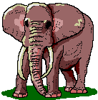
The first blind man put his hand on the shoulder of the young boy who would guide them home. The second blind man put a hand on his friend's shoulder, and so on until all six men were ready to travel together.
A Tragedy of Miscommunication: True Story
During the Vietnam war a soldier was ordered to guard an ammunitions building. His orders were to shoot and kill anyone who came near the building. This was necessary because too many times a soldier had been blown up by someone carrying a bomb.
One particular night a woman came toward him. The young soldier yelled out for her to stop, and waved her away with the back of his hand. The woman still come toward him. He continued to wave her away; ordering her not to come any closer, but the woman didn't understand English and continued to walk toward him. The man had been ordered to shoot anyone who came near. She wouldn't stop coming toward him no matter how many times he begged her to go back! The young soldier followed his orders; he shot and killed her.

Several years after the war, the man was attending college. One of his classes was on language communication. The teacher was telling the students how different cultures use their bodies in different ways to communicate. "For example", the teacher explains, "in Vietnam the hand signal directing someone to come to you is the same as our hand signal directing people away. The hand gesture meaning 'go away' to us, means 'come here' to them."
The man twisted uncomfortably in his chair as he realized a terrible tragedy had taken place. A mistake he could never correct.
After class the man went to speak to his teacher. The teacher could see how upset the man was as he began to speak. He explained to the teacher what happened all those years ago, and how he didn't know about the hand signals being different until that day in class.
The man told his teacher, with tears in his eyes, "If I had only known the hand signs were different. She was only doing what I was telling her to do, and I killed her.

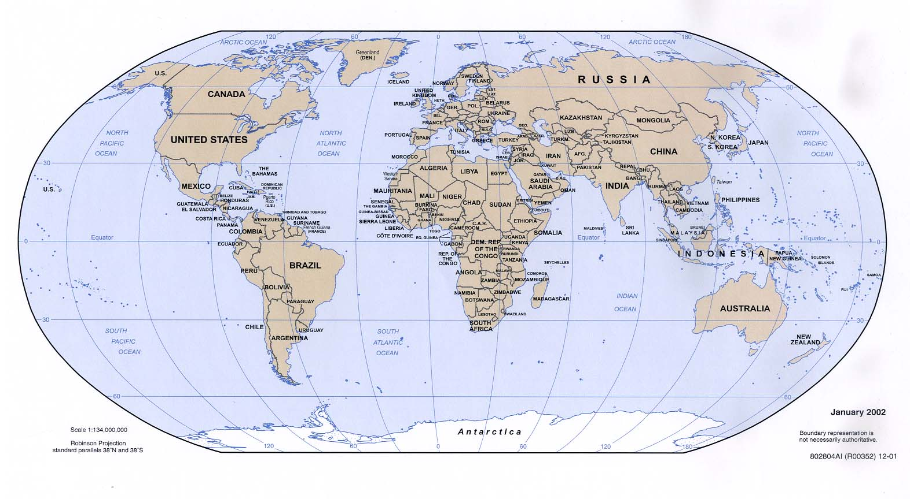

Terms First definition Second definition

culture
adapt
change
society
beliefs
ideas
Multicultural
Bicultural
Gender
Social change
Cultural change
Socio-economic

What makes me me?
Think of your family.
• How and why they dress the way they do?
• How and why they celebrate certain holidays?
• The foods they eat and the way they’ve been taught to eat them?
• What is the polite thing to do?
• The traditions in their family?
• What is important to them?
• What influences and shapes the way they think and act?
Put your name in the middle of the circle. What words would you use to describe yourself?
1. Share a story about a time you were especially proud to identify yourself with one of the descriptors you used above.
2. Share a story about a time it was especially painful to be identified with one of your identifiers or descriptors.
3. Name a stereotype associated with one of the groups with which you identify that is not consistent with who you are. Fill in the following sentence:
I am (a/an) _____________________ but I am NOT (a/an)_____________________.
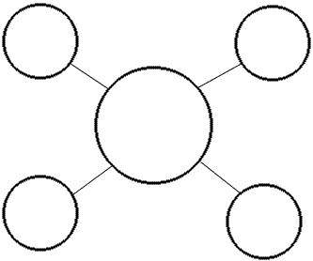

Character Investigator
Compare characters in video/picture books.
Character Comparison
Date:___________________________
Title:___________________________

A character in this book reminds me of: (Examples: a book, someone I know, etc.)

How they are alike . . .How they are different . . .

How have Maori and Pakeha Cultures Interacted in New Zealand?
Cut out and match the date to a statement in a box and a diagram in a circle
The Maori and Pakeha are 20,000 km apart. Because there is no interaction betwwen them they cannot influence each other
The British culture is dominant over the Maori culture. A few Maori traditions and customs remain in pockets around the country. Maori culture (despite the Treaty of Waitangi) is struggling to survive.
Traditional Maori Lifestyle
Traditional British/Europeon Lifestyle
Maori wear British clothing, live in British style houses and speak Bristish language.
The British government becomes government of NZ
Christianity becomes main religion
Rule of law favours European immigrants
Many important places are given British names
Most Maori still live in Traditional Maori Lifestyle
Chinese
Pacific Islanders
Korean
Indian
Before 1769
1769- 1839
1840-1970
1970-2000’s

National recognition is given to Maori culture. The British culture still dominates the life of Maoris, but Maori culture is re-emerging. The British culture in turn is being affected by other world cultures.
Intermarriage,trading, conflict, learning each others language, influence of missionaries

Most British still live in Traditional British Lifestyle
As people look into the culture of NZ what do they see?
British culture still dominant, but is being infused by other cultures.
Maori language nests
Maori fishing rights and land compensation
More organisations
& individuals celebrate and
learn Maori culture
While mostly living in a European lifestyle many Maori seek to establish Maori traditions and rights
The Maori and British cultures make contact. Their two ways of life start to interact.

